HILLY FIELDS FOOTBALL CLUB
SEASON 15: 1981-82
RESERVES:
BECKENHAM LEAGUE:
P W D L F A Pts Pos
Division 2 16 7 2 7 35 37 16 5th
Beckenham League Cup 3 2 0 1 7 5
Beckenham Hospital Cup 2 1 0 1 5 3
Burwood Cup 3 2 0 1 11 4
Friendly 5 4 0 1 12 7
TOTAL 29 16 2 11 70 56
Apps Gls Apps Gls
Steve Banks 24 0 Trevor Lambert 1 0
Colin Chandler 17 4 Gary Lattimore 2 0
Steve Clarke 11 4 Clive Le Baigue 16 0
Simon Crosskill 2 0 Jimmy Lee 5 0
Paul Eustace 5 0 John McGilvray 14 1
Sabino Favirito 3 0 Mickey Michalle 29 3
Dave Ford 3 0 Alan Middleton 3 0
Len Franklin 23 0 Neil Muncey 6 2
Larry Garnham 23 1 Luis Navarro 3 0
Jim Hammersley 2 1 Dave Norman 10 3
Eddie Hicken 18 3 Steve Reeves 3 0
Malcolm Hill 4 2 George Sibley 2 0
Steve Hollowbread 2 1 Graham Smith 26 28
Bob James 28 6 Albert St Clair 1 0
Mike Jefferys 25 0 Winston Vaz 1 0
Phil Jesson 18 0 OG 1
Steve Knight 3 0

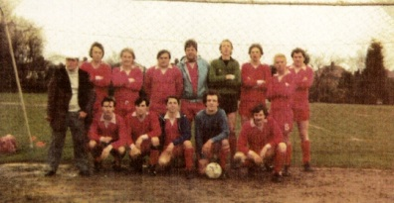

L-R BACK: Jim Hammersley, Jimmy Lee, Mike Jefferys, Eddie Hicken, Colin Chandler, Phil Jesson, Clive le Baigue, Steve Clarke, Len Franklin, L-R FRONT: Graham Smith, Luis Navarro, Mickey Michalle,
Bob James, Steve Banks

